

MÓDSZERTANI SZOCIÁLIS KÖZPONT ÉS INTÉZMÉNYEI

B U D A P E S T I

Budapest methodological
Centre of SOCIAL POLICY
AND ITS INSTITUTIONS

July 2005.

Budapest Methodological Centre of Social Policy and Its Institutions (Budapesti Módszertani Szociális Központ és Intézményei) was founded in 1993 by the Budapest Municipal Council, but it is an independent legal entity with its own budget. The financial resources are provided by the Municipal Council and by the state. In order to provide higher level service, the Social Services Centre also enters competitions to access additional funds. The EQUAL Programme aimed at improving the employability of the homeless is funded by the European Union and the Hungarian State; whereas Cooperation Public Foundation (Összefogás Közalapítvány) supports the subsidised housing programme.

Budapest Methodological Centre of Social Policy and Its Institutions is the largest service provider for homeless people. Its 17 centres work on a wide range of services aimed at the diverse homeless population.

- The hostels can accommodate 937 people. The shelters can provide overnight stay for 373 rough sleepers.
- Special shelters serve as temporary housing for homeless mothers with children.
- Day centres are daytime shelters for the homeless.
- Street social workers trace rough sleepers and help them in getting institutionalised support.
- The Medical Care Crisis Service (Orvosi Krízis Szolgálat) reaches out to the homeless needing medical assistance.
- Budapest Methodological Centre of Social Policy and Its Institutions also acts as the regional methodological centre for homeless services in the Central Hungary region.

Budapest Methodological Centre of Social Policy and Its Institutions employs 163 social workers and 65 social assistants altogether.

Activities of the methodology centre

- Preparing strategic decisions;
- Improving cooperation;
- Supporting social work at all levels of homeless care;
- Setting the standards for social work;
- Creating a framework for quality assurance.

This comprises the following responsibilities, in cooperation with Shelter Foundation (Menhely Alapítvány):
- Consulting with local councils and government authorities on the professional background of homelessness legislation.
- Organising workshops and professional trainings related to homelessness services, social services and housing.
- Professional support, initiating and organising new regional services.
- Operating a coordinator network.
- Managing the EQUAL Programme.
- Publishing professional studies, including the series "Homeless.... Action for People". (Otthontalanul.... Tégy az emberért!)
- Editing the periodical "Ferrymen" (Révészek) targeted at the employees of the Budapest Methodological Centre of Social Policy and Its Institutions.
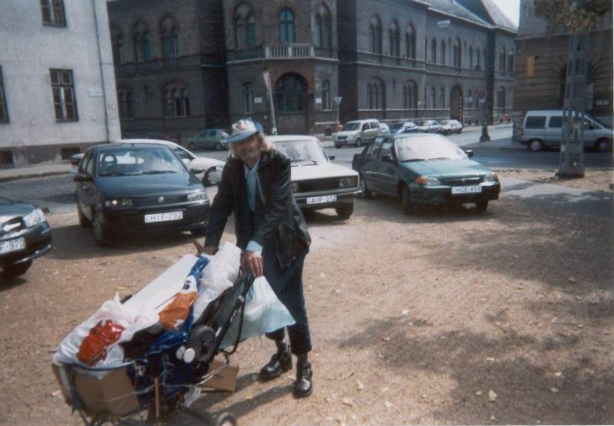
- Coordinating the so-called annual "February 3 survey" of the roofless population in Budapest.
- Running arts projects, competitions, exhibitions for homeless artists.
Structure of the Services

The Budapest Methodological Centre of Social Policy and Its Institutions has a multi-level structure, in line with the complex needs of the homeless population.
One of the basic pillars is the coordinator system, which comprises the four key areas of tackling homelessness:
- employment,
- housing,
- addictology,
- social care centres / nursing homes.
All the above areas have their own coordinators at the service centres who trace changes and possibilities and can provide up-to-date information. With the help of the coordinator network, the experts based at the service centres can forward information to their teams.

- In order to increase efficiency, the service centres specialise in tackling a particular type of crisis. In the case of hostels, Kálvária Hostel accommodates and rehabilitates homeless people with special health care needs. Bánya Hostel prepares clients for admission into nursing homes. Váltó Hostel cares for homeless with substance abuse problems. Külső Mester Hostel aims at reintegrating the homeless clients into the labour market.
- All social centres provide services and care to satisfy the individuals' needs. A personal social worker is assigned to each client, who is responsible for surveying the person's needs, physical and mental condition; providing information and mental support; and assisting with applications and other paperwork. Social workers and clients draw up and sign a Cooperation Contract. The social workers also prepare a Plan for Social Work, document the necessary steps to be taken, the commitments of both parties in the cooperation, and the achievements. These plans are assessed, monitored and changed if necessary by the social worker and the professional team of the social centre.
- In order to supplement one-to-one social work and thus improve efficiency, social centres also organise group sessions, either in the form of clubs run by professionals (e.g., groups to facilitate admission to nursing homes, job-seekers' club), or self-supporting groups (e.g. Alcoholics Anonymous).

 | Social centres | Maximum number of clients | Number of social workers and social assistants
1. | Street Care Service | - | 4
2. | Fehér Day Centre | 120 | 8
3. | Western Railway Station Day Centre and Shelter | 70  30 | 10
4. | Könyves Shelter + | 40 | 14
 | Könyves Day Centre | 50 | 14
5. | Előd Social Centre | 208 | 18
6. | Dózsa Shelter and Convalescent Centre | 200 | 18
7. | Hostel for Mothers with Children | 14 | 5
 | 4 temporary homes | 12 | 5
8. | Medical Care Crisis Service | 73 | 21
9. | Táblás Centre | 80 | 14
10. | Kálvária Care Centre | 48 | 8
11. | Váltó Centre | 66 | 25
12. | Bánya Centre | 64 | 12
13. | Külső-Mester Centre | 129 | 16
14. | Alföldi Special Centre | 221 | 24
15. | Dózsa Hostel | 326 | 40
16. | Kocsis Hostel and Students' Dormitory | 430 | 17
17. | Methodology team | - | 8
 | Altogether: | 2181 | 262

A brief description of the centres and services run by Budapest Methodological Centre of Social Policy and Its Institutions

STREET CARE SERVICE

Social workers assist homeless who are roofless, do not trust day centres or shelters, and thus do not receive any other institutionalised help. Care includes social and mental support, life saving in emergencies, prevention and integration. The street care service cooperates closely with other service providers working in the streets.
Time and location of street care service is as follows: midday to midnight in the whole municipal area, from November 1 to March 31; 10 a.m. to 10 p.m. in two districts and in the vicinity of Western railway station from April 1 to October 31.
4 social workers are permanently employed, 2 additional workers help out in the winter. 185 new clients were contacted in 2004 and assistance was provided on 1542 occasions.

Fehér DAY CENTRE

The day centre provides possibilities for socialising, relaxing, personal hygiene, washing, cooking and eating.
Other services provided by the centre include:
- Jobseekers' club: participants inform each other, share experiences on potential employers, browse job openings and make calls to inquire about the jobs.
- Arts and crafts club: participants make drawings, paintings, small objects.
- Computer club: participants can study basic computer literacy, write CVs and emails to apply for jobs.
- Film club: participants watch films of their choice; there are also books on loan for 1-2 weeks.
- Medical Care is available at the day centre once a week.
- Social workers are available for individual consultation, to seek advice on individual problems, and to get information on possibilities for moving away from rough sleeping.
In 2004, there were 114 clients a day on average, most of them regular visitors. There were altogether 42,915 "visits" (38,908 male and 4,187 female).
The day centre is open from 9 a.m. to 3 p.m. on Mondays, from 9 a.m. to 5 p.m. from Tuesdays to Fridays. In wintertime and on holidays, services are available from 9 a.m. to 3 p.m. The centre is run by 4 social workers and 4 social assistants.

WESTERN RAILWAY STATION CENTRE

The centre was set up in February 2005, with 20 (+10) beds in the shelter and a capacity of 70 homeless clients in the day centre. The centre caters for the roofless population staying permanently at the railway station and in the adjacent underpasses, who had refused daycare and night shelters previously offered to them.
The day centre is open to all homeless in need from 8 a.m. to 6 p.m. Monday to Friday. Services are provided by a staff of 8 social workers and 2 social assistants.

Könyves SHELTER AND DAY CENTRE

The centre typically caters for homeless with jobs near the city centre. Clients can stay at the hostel for 30 (+ 30) nights and get assistance in finding a vacancy at a hostel or workers' hostel.
Shelters are open to all those who:
- have Hungarian citizenship,
- or have permanent resident immigrant status,
- or have been registered as refugees,
- are over 18 years of age,
- are capable of taking care of themselves,
- have no other housing,
- present a hygiene document not older than 7 days on admission,
- present a negative lung screening document not older than six months,
- identify themselves with the appropriate documents,
- sign a document accepting the house rules on admission.

Services provided by the centre:
- Those who work at night can stay during the day.
- Rent subsidies for rough sleeping couples.
- Care for dogs: while the homeless take a rest, have a wash, or wash their clothes, their (often only) canine companions are sheltered and fed.
- Library (600 volumes) and video club.
- The day centre can accommodate up to 50 men and women, the shelter is open to up to 75 men. 9 social workers and 4 social assistants work at the centre.

Előd SHELTER

The centre can provide overnight accommodation for up to 140 clients during the summer, which is supplemented to 232 beds during the winter, making it the largest shelter in Budapest.
Services provided include:
- bunk beds in dormitories accommodating 16, 24, 36 and 48 people;
- laundry room and bathrooms;
- facilities for cooking and eating,
- support by social workers.

The shelter is divided into three separate areas.
Rough sleepers coming in from the street and in need of mental and physical re-socialisation into a community are accommodated in 6 dorms. Another 6 dorms are reserved for regular clients whose condition makes them fit to find employment or joining training courses and thus move away from the hostel. Special care is provided to 40 clients on a separate floor.
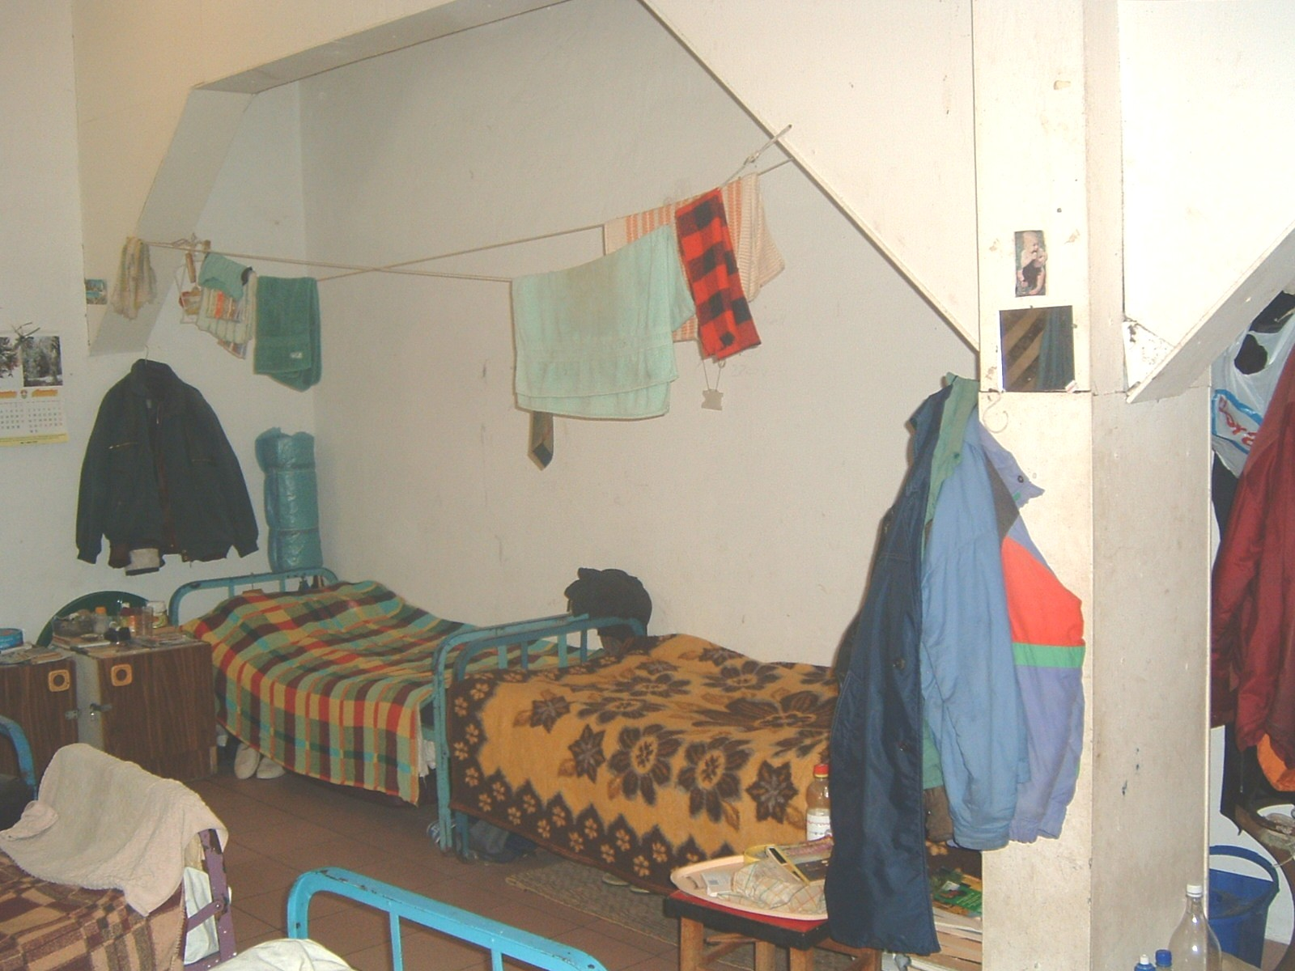

Dózsa HOSTEL FOR MOTHERS WITH CHILDREN

The hostel is open to mothers with children who are temporarily homeless or in crisis because of domestic violence or the socio-economic status of the family.
Up to 16 people can be accommodated for 1-5 nights in the hostel comprising 4 rooms, common areas for dining, cooking, washing and socialising, and an office. 3 apartments are available as temporary housing for a further 12 people.
The 5 social workers at the centre aim at finding safe accommodation for the mothers with children during their short stay: possibilities include ensuring places at family hostels, mothers' hostels, or rented apartments.
205 mothers and 352 children found temporary refuge and assistance at the hostel in 2004.

Alföldi HOSTEL AND SPECIAL SHELTER

The centre can cater for 173 clients in dormitories with 20 beds. A specially refurbished area is available for the physically handicapped; abstinent clients are accommodated separately; and two rooms are reserved for deaf clients.
Services provided at the centre:
- Training for jobseekers,
- Rehabilitation for the physically handicapped (by therapists),
- Clubs, individual consultation and programmes to prevent relapse to alcoholism for clients aiming to achieve abstinence,
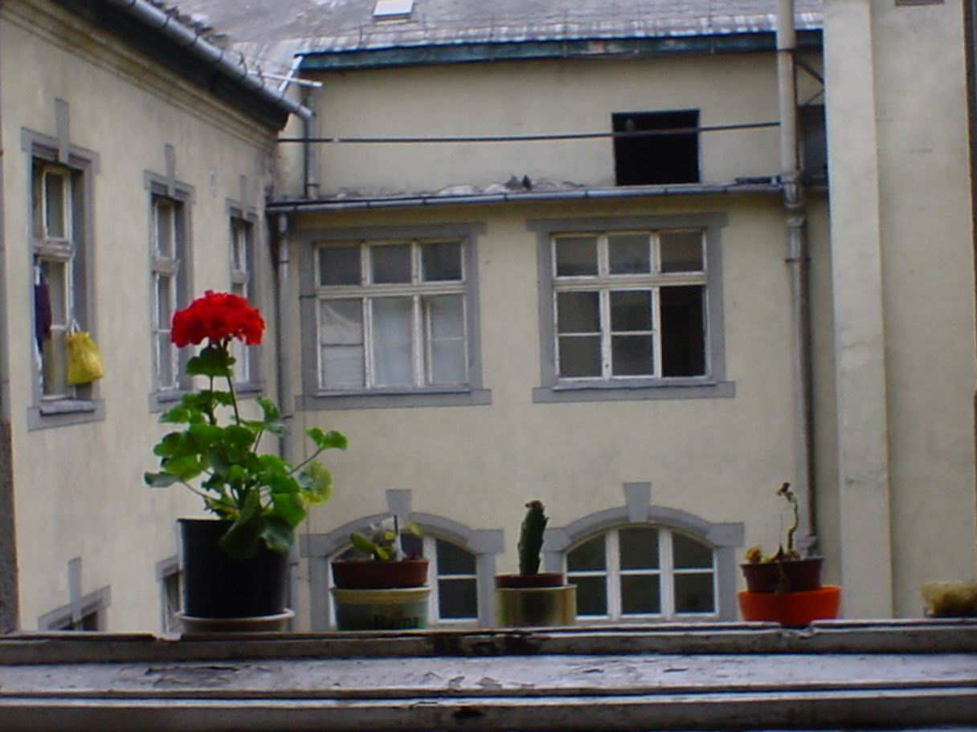
- Gym, film club, arts and crafts club, games, library, visits to museums.

In 2004, 122 clients moved into the hostel and 153 moved out.
Erzsi folyamatábra??!

Táblás speciAL HOSTEL

Homeless clients can be admitted if they sign a contract to participate in the compulsory saving scheme.
There is accommodation for 80 people in 2 and 4-bed rooms. Couples can be admitted into the double rooms. The "couples programme" aims at facilitating their reintegration and access to housing through the saving scheme and rent subsidies.
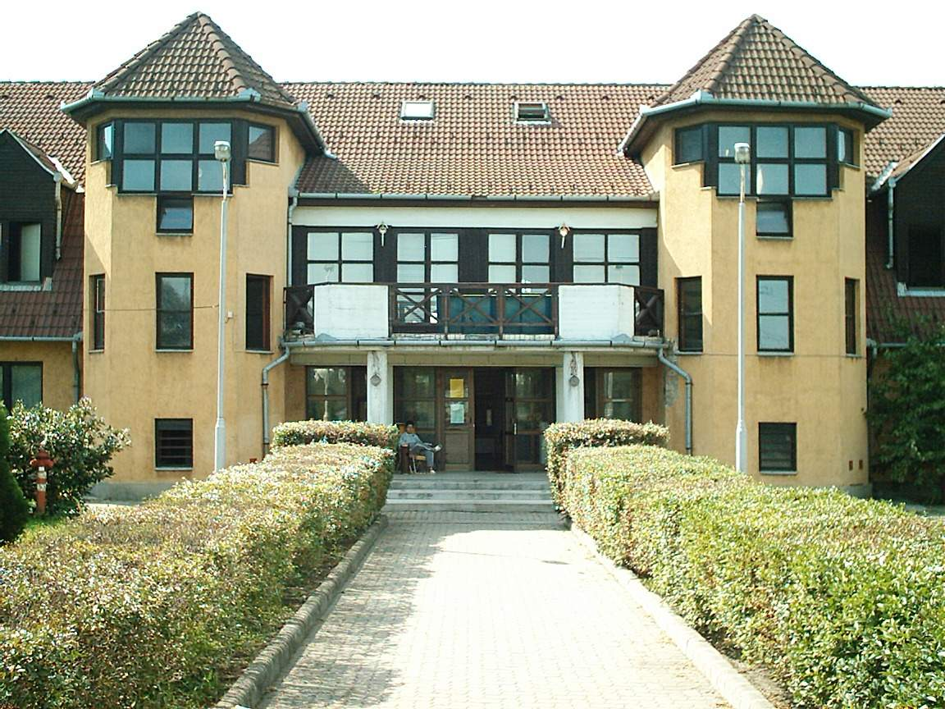

Dózsa SHELTER

103 beds in two dormitories can accommodate single homeless women on an occasional basis, for one night at a time.
Services at the centre:
- "Reintegration programme" is aimed at preparing clients with an institutional-based lifestyle to cope with independent living and at providing chances for a fresh start. A moving-out subsidy is available for participants in the programme; the chance was taken by 15 clients in the first phase and 46 in the second phase.
- "Street programme" is aimed at providing occasional accommodation for rough sleeping couples in three apartments rented by the centre, and at ensuring follow-up care.
The moving out subsidy is available for clients staying at the hostels or shelters of the Budapest Methodological Centre of Social Policy and Its Institutions.
The programme spans one year, with two supplementary phases: moving-out subsidy and rent subsidy for those leaving the shelters or hostels, and follow-up care supporting reintegration. Financial support is available for 11 months and decreases gradually. Sessions with the case social worker are frequent in the first 4 months. Clients can learn and adapt to living independently and pay an increasing share of their rent. By the end of the year, they are capable of supporting themselves mentally and financially.
The programme is open to those who:
- are married or live in partnerships but have been forced to stay separately at the hostels;
- would like to move out to a rented apartment on their own or together;
- have been cared for by the centre for at least 3 months;
- are capable of supporting themselves;
- have regular income which covers the rent and expenses if supplemented by the subsidy;
- participate in the saving scheme while staying at the centre;
- sign a cooperation contract with their social worker.

DÓZSA CONVALESCENT CENTRE

This centre provides medical facilities and three dormitories for 40 rough sleeper men whose medical condition does not need professional hospital care but would get critical if they continued roofless.
The centre provides the following services in wintertime: daycare and night shelter, three meals a day, hygiene facilities, bedlinen, medical care, social care, mental support, medication, clothing and hospital care if necessary. Medical doctors are present two hours a day (four hours during the winter), nursing staff is on duty non-stop.

Kálvária CARE CENTRE

The care centre can accommodate up to 48 homeless people (20 women and 28 men) in 1, 2, 3 or 4-bed rooms. 19 places are suitable for the physically handicapped. The centre provides for homeless with special needs because of chronic illness or handicap, and addresses problems during the health and social rehabilitation period.
The following services are available:
- care adapted to the special needs of the individual;
- social and mental care;
- extended health care;
- a discrimination-free community.
The integrated social services aim at helping clients to regain the physical and mental condition corresponding to their age and abilities.
In 2004, 58 clients were served at the care centre.

MEDICAL CARE CRISIS SERVICE

PRIMARY HEALTH CARE
There are no administrative limitations to accessing the standard primary health care services.
The service is a key element of social work in the streets: doctors receive patients directed to care by social workers or transported by the crisis car, act in emergencies, perform disinfection if necessary, and forward patients in serious condition to suitable inpatient care or specialist care.

Special service
Vital medications are available free of charge to patients with financial problems.
The health care centre is open from 8 a.m. to 8 p.m. daily. Three medical doctors are on duty. A doctor in attendance is available at night and at weekends. In 2004, 852 homeless patients were served on 9265 occasions. 7-25 clients were usually served during the 4-hour shifts (14 on average). 725 patients needed care outside daytime office hours.

STREET MEDICAL SERVICE
The street medical service provides basic care and emergency care at day centres and shelters. Its most important tasks are to reach homeless who are otherwise outside the care network but need regular checkups, to direct homeless in critical condition to medical care, and to vaccinate the population as a preventive measure if necessary.
In 2004, the medical service was called on 252 occasions and provided care to 3138 patients.

SPECIAL CARE
The Medical Care Crisis Service also provides special care in psychiatry, neurology, dentistry and dermatology.

INPATIENT CARE
The Chronic Medical Ward has 50 beds for inpatients, and the Nursing Ward can accommodate 23 inpatients. The first one provides for homeless needing hospital care and attendance because of their general condition or illness. The Nursing Ward focuses on supervision by nursing staff, with the participation of internist, surgeon and psychiatrist specialists.

Supplementary services:
- Social work for each inpatient, including personal care;
- Mental health care with the help of an addictology specialist, hospice workers, volunteer care workers;
- Physical rehabilitation.

In 2004, 434 homeless needed inpatient care.

Váltó CENTRE

This rehabilitation centre is open to homeless with substance abuse or other addiction problem, on condition that they agree to abstinence and self-support group therapy. The aim of the programme is to strive for permanent abstinence and to impart the necessary practical guidance for an independent lifestyle.
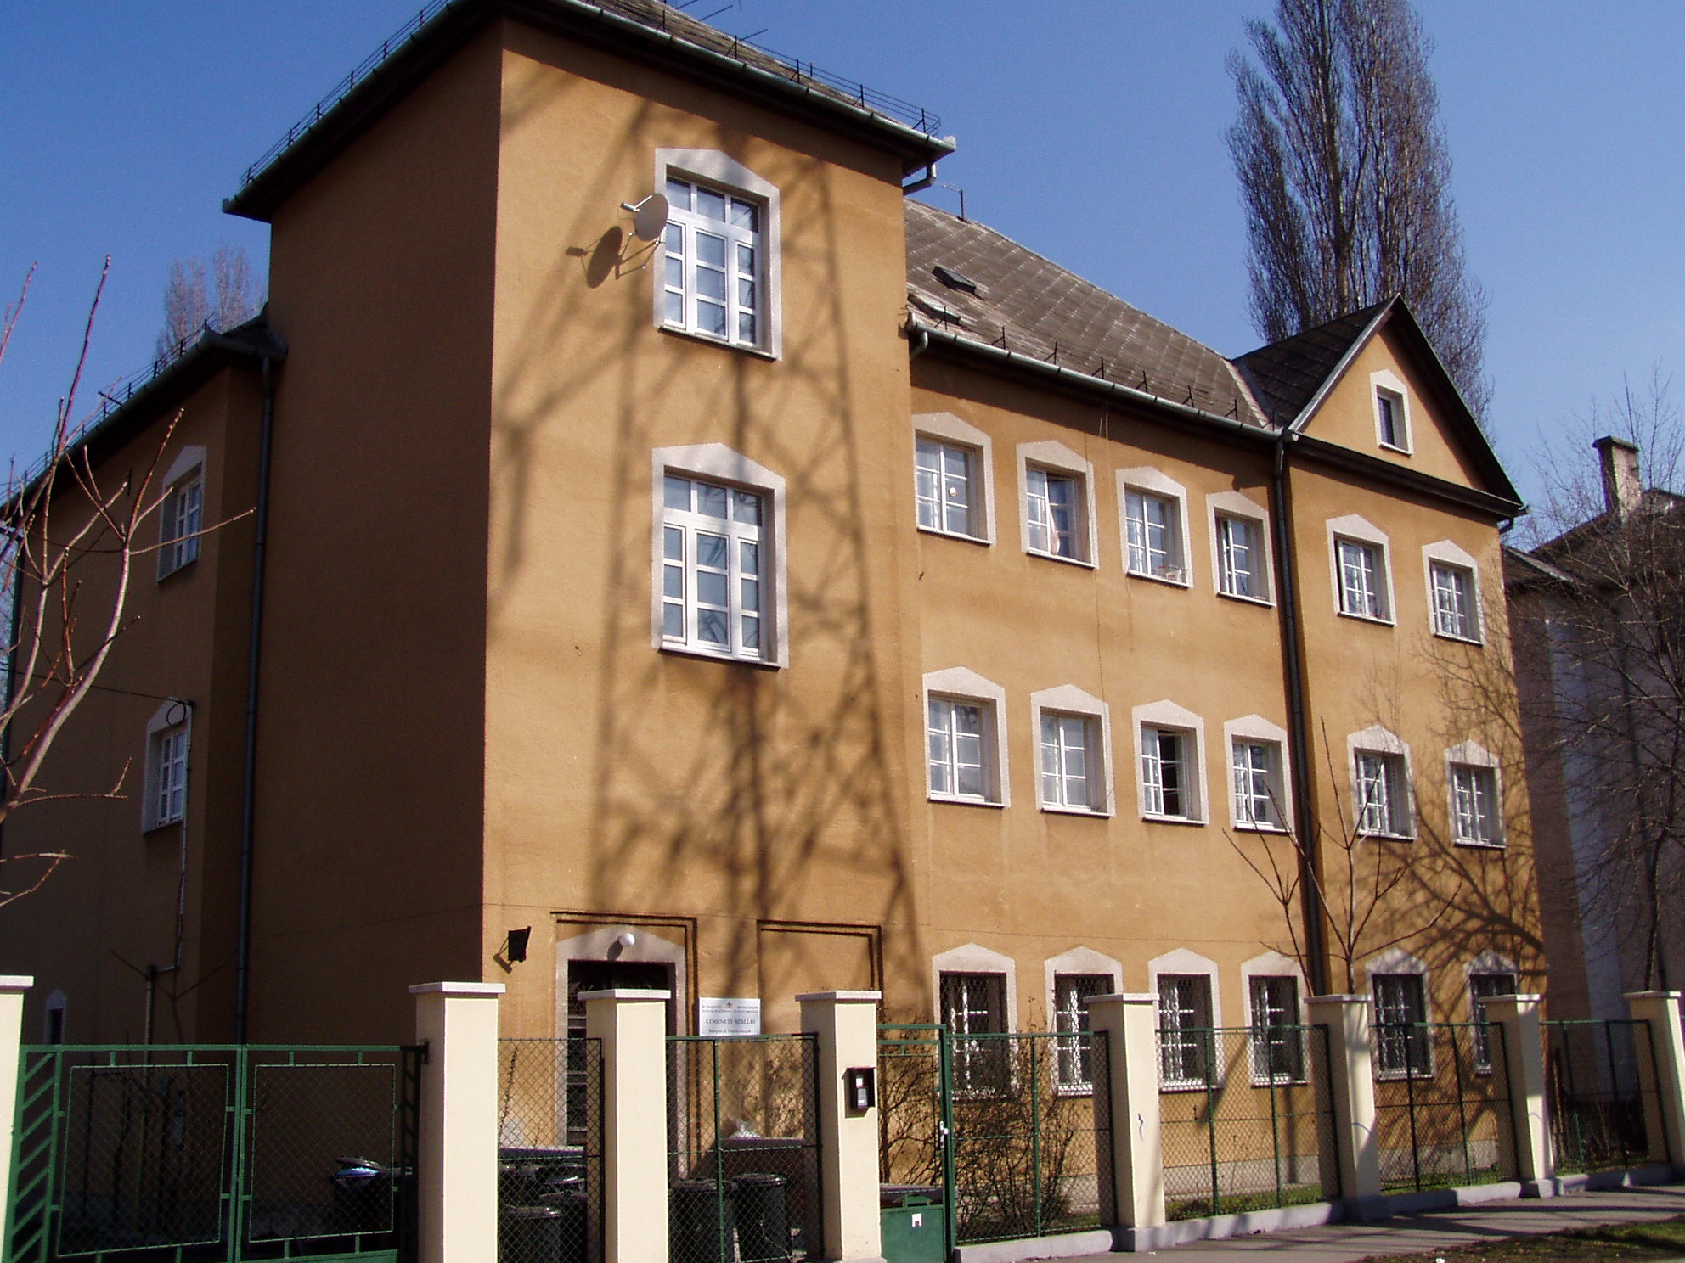
The programme comprises the following:
- "Let's talk" – a self-support group, with no outside help.
- "Universe group" – getting to know each other and the world with the help of professional techniques, self-recognition and drama.
- Film club – discussion group based on selected films.
- "Pulse" – an open group with the aim of developing communication skills, self-consciousness, and participation in community life.
- "Stay sober" – relapse prevention group
- Learning basic computer literacy in the computer room.

The centre provides care for 66 homeless people (56 men and 10 women) in 4 and 5-bed rooms. In 2005, 47 residents left the centre, of whom 45% were abstinent at the time.
Shelters are free of charge. There is a service fee at some of the special shelters and hostels:

Külső Mester Hostel 5.300 HUF/month
Dózsa Hostel 6.600 HUF/month
Alföldi Special Shelter none
Alföldi Hostel 3.600 HUF/month
Kocsis Hostel 6.000 HUF/ month
Kálvária Hostel 6.000 HUF/month
Bánya Hostel 3.900 HUF/month
Váltó Rehabilitation Centre 4.900 HUF/month

(Clients can submit an application for a reduced fee.)

Bánya CENTRE

The hostel provides services for those who are awaiting admission to nursing or social homes (old age homes, mental homes, mentally handicapped homes). 64 elderly, ill or handicapped men can be admitted to the centre, who are accommodated in 10-bed dormitories. 2 rooms are reserved for abstinent patients. Social work is aimed at keeping in contact with the nursing or social homes providing long-term housing and care, and at facilitating integration into the institutionalised lifestyle in these homes.

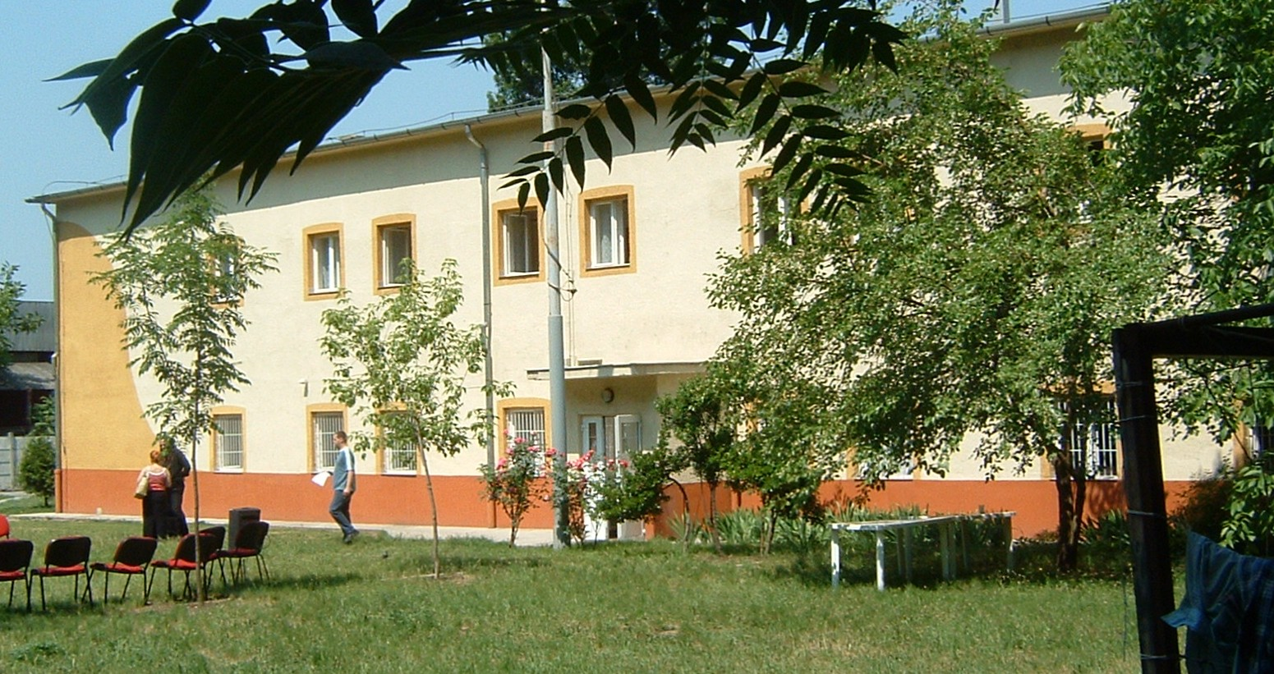
Group sessions:
- Preparation for life at the nursing home.
- "Let's talk about ourselves" – building communities and improving social skills.
- Addictology group.
- In 2004, 29 clients left the care centre, 11 of whom moved into nursing homes.

Külső Mester HOSTEL

The hostel provides temporary housing for 129 homeless men who have income from permanent jobs or other regular employment, or take part in subsidised training courses. Social work at the centre focuses on reintegration and advance on the labour market.

Special services provided by the hostel:
- Computers are available for those participating in training programmes.
- "Addictus group" – helps fighting addiction and maintaining a sober lifestyle.
- Gardeners' group – maintains the park belonging to the hostel.
- Basic computer literacy course.
The hostel accommodated 265 men in 2004: there is high turnover, the average client stays months, not years.

Dózsa HOSTEL

326 homeless people (230 women and 96 men) can be accommodated at the largest facility operated by the Budapest Methodological Centre of Social Policy and Its Institutions.
Special services provided by this centre include:
- Training and retraining programmes.
- Taxi driver programme – clients who have passed the relevant exams can work as individual entrepreneurs.
- "Move-on apartments" for clients with safe permanent jobs.
- Rent subsidy.
- Apartment programme – aimed at maintaining or reviving family relationships broken because of homelessness.
- Arts and crafts, library with 4,000 volumes, computers with internet access.
- Visits to museums and other cultural programmes.

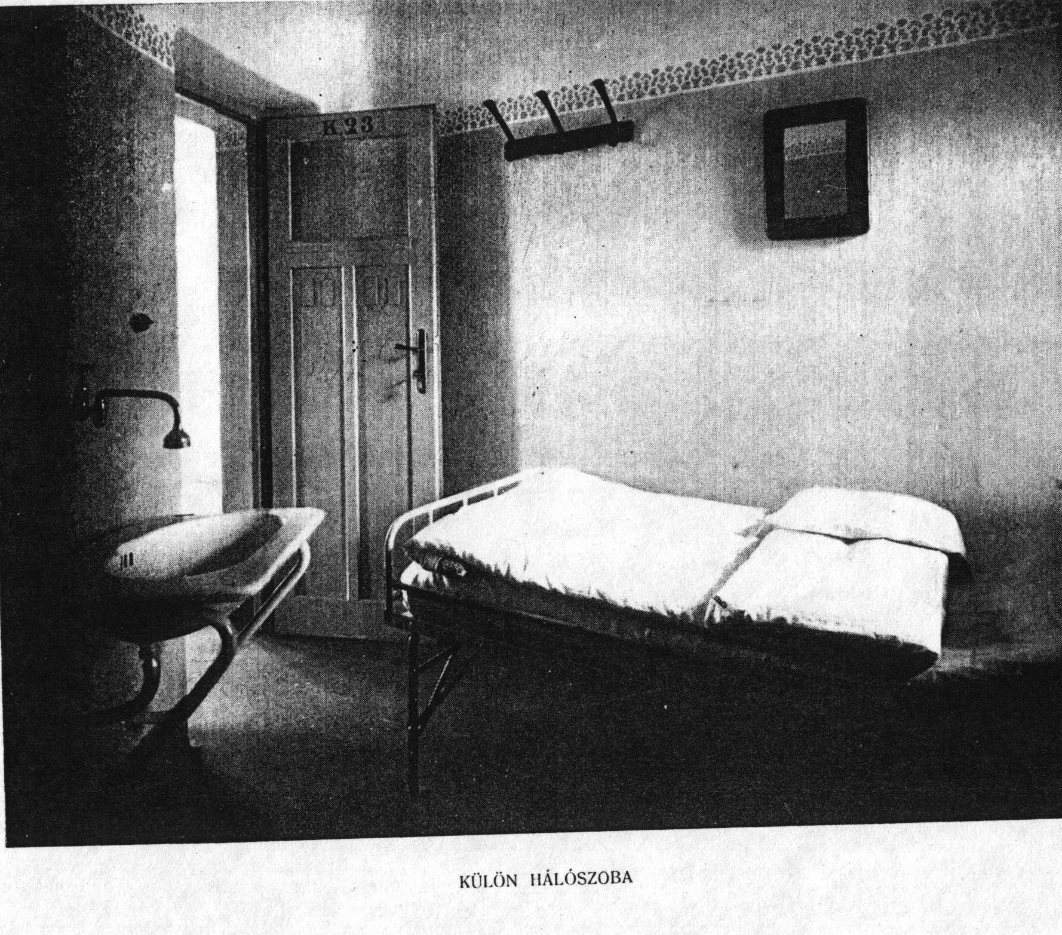

Kocsis HOSTEL

Out of the 15 floors of the centre, 5 floors are taken up by the homeless hostel, community area covers 2 floors, whereas the remaining 8 floors operate as workers' and students' dormitories. The total capacity is 430 people.
The following services are provided by the hostel:
The most modern hostel of the Budapest Methodological Centre of Social Policy and Its Institutions is furnished with new equipment, all rooms have fridge and cable tv. Clients have access to medical care, parking, left luggage and safe deposit service, fresh bedlinen, laundry room, kitchen, cafeteria, library, computer room with internet access and a gym.
The centre is a transition between social housing and homeless hostel. There are 10 double rooms, 30 4-bed rooms and 10 5-bed rooms. Clients (both men and women) are admitted if they have regular jobs, pay 6,000 HUF / month rent, and participate in the compulsory saving scheme with a monthly minimum amount of 15,000 HUF.
Couples are accommodated separately.
Rooms in the workers' hostel section are available at low rates for workers or employers.

Compulsory saving schemes are an important part of social work at the hostels. The aim is to facilitate starting independent living when moving out, as the saved amount can be spent on rent or rent deposit. The minimum sum is determined by the hostel, its exact amount is set based on individual situations (personal income and expenses). Participation in the saving scheme is usually a precondition for admittance into hostels.
Külső Mester Hostel 5,000 HUF/month
Dózsa Hostel 5,000 HUF/month
Alföldi Special Shelter 3,600 HUF/month
Alföldi Hostel (none)
Kocsis Hostel 15,000 HUF/month
Kálvária Hostel 6,000 HUF/month
Bánya Hostel (none)
Váltó Rehabilitation Centre (none)

