Housing First
project of Habitat for Humanity Hungary

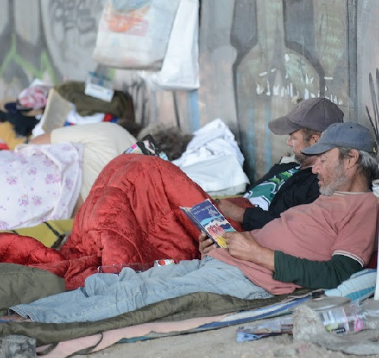
Background
Housing First projects show that rather than moving the homeless through different "levels" of housing (eg. from the streets to a public shelter, and from a public shelter to a transitional housing institute), Housing First moves them from the street into their own apartments. A lot of rough sleepers averse of institutions, they don’t like the rules and conditions of them but could maintain a home, and in Hungary there is not enough place in shelters too. The Housing First approach is based on the concept that a homeless household's primary need is to obtain stable housing, and that other issues that may affect the household can and should be addressed once housing is obtained. Housing First options can change a 10-15-year rough sleeper’s life.
Habitat for Humanity believes that symptomatic treatment is not enough to reduce homelessness. A complex housing policy is needed to prevent people from losing their homes. Temporary homeless care won’t show a way out, but homeless people need to have the opportunity of a normal home and complex care to be able to keep their housing on the long run. That’s why we started Housing First projects.

Our approach
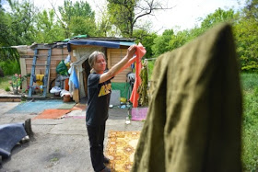
About 15,000 – 30,000 people continue to be homeless in Hungary. Although the number of people living in public spaces dropped significantly, one of the possible reasons for this beyond the expansion of institutional placements is that people are hiding from the public eye for fear of possible sanctions. One of the dominant social debates from 2012 was about whether homelessness should be considered a social or an esthetic-criminal issue.
Most city municipalities adopted local decree to outlaw homeless person living in the street. Several homeless people were fined or were taken into custody for living in public space. Homeless people sometimes build their own huts and shack in abandoned public spaces using discarded materials and leftovers from construction sites. The municipality can bulldoze them almost any time, and they can be fined for building these shacks without the permition of the owner (usually the municipality). So it is very important to find innovative ways to create secure, affordable and independent housing for homeless people.
On the other hand the rate of affordable social housing is very low (In 2010 3.6% of the total population rented municipally owned apartments). But still there are more than 15 000 empty flats owned by the municipalities they are mainly in bad condition, not suitable for living.
In our approach we’ve contacted municipalities. In our partnerships we are renovating empty and bad condition municipality flats with the help of volunteers. Habitat for Humanity is known around the world about engaging volunteers in creating homes. In our buildings the beneficiaries and volunteers are working together, they get to know each other, and we can raise awareness for the problem,
We are also working very close with street social worker organizations. As they have direct connection with the people living in the street. Our approach builds on intensive social work, so street social workers contact and engage people to the project, they help them to prepare independent living, and an intensive after care is also needed for them to be able to keep their home for long term.

Our achievements in the past
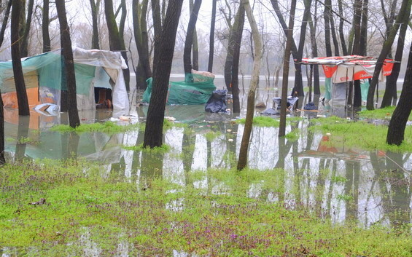
In 2014 (mainly with the support of Aktion Deutschland Hilft) we helped 10 homeless households to find a permanent and affordable home. In this project the participants moved to renovated social rentals. Our partners (the City is for all, Maltese Charity, Baptist Charity and Twist Oliver Foundation) provided them complex and intensive social work, to prepare them to move to their flats, and to help them keeping it.

Future Plans
HFHH is planning to work with more municipalities as we established good connections and found more opportunities than we thought. We will start a long term project for 3-5 years, in which we could help about 5 homeless households living on the street or in self build shacks, into apartments each year (with the support of Fundacion Abbe Piere and Saint-Gobain Initiatives).

About Habitat for Humanity Hungary
Habitat for Humanity is a global nonprofit organization that seeks to eliminate poverty housing. We believe that a decent and sustainable home is a basic human right. Habitat for Humanity in Hungary was founded in 1996. Since then we have helped more than 2000 families. 149 families could move into a new home, 550 families have been served with repair and renovation projects and 1300 families have participated in trainings.
We started our work with the traditional Habitat model that is, building new homes with the participation of volunteers as well as the families. We have successfully started the Habitat Resource Center (Habitat Pont) model in 2013 - a sustainable model for the support of the upkeep, repair and improvement of rural households living in and close to deep poverty. Habitat Resource centers are hubs enabling home improvement with a range of services including advice in technical matters (construction technical assistance or CTA), tool rental and the sourcing of recyclable materials. 1.2 million people are affected by poverty housing in Hungary. To address the need a more socially sensible housing policy is required. For this reason we started an advocacy work beside the construction projects and educational programs that we run.

For further information:
Koltai Luca / Ms. Luca Koltai Chief Operations Officer
Mobil: +36 20 364 89 02 E-mail: luca.koltai@habitat.hu
HFH International Hungary Nonprofit Kft. - 1065 Budapest - Hajós utca 9.
Tel.: +36 1 3541084 - Fax: +36 1 3541085

