The formation of the National Group of Allies in Ireland

Supporting women experiencing homelessness involves a wide range of organisations and services because homelessness impacts on all aspects of a woman’s life and can be experienced differently by different groups of women. A common cause of women’s experiences of homelessness are gender inequities that produce barriers to accessing the resources needed to secure and sustain safe and secure housing. Support for women experiencing homelessness comes not only from specialist homelessness services—such as outreach teams, day centres, and shelters—but also community mental health and addiction support programmes, as well as family support and child protection services, including accommodation and support for pregnant women and new mothers, specialist treatment centres for mothers and babies and health care teams including public health nurses and maternity specialists. However, in many cases, these services are run by different organisations, with limited knowledge of homeless women’s specific needs or/and each other's work or available programmes.
The aim of the Women's Visual Voices project is to ensure that the experiences of homeless women shape the services provided for them, and that organisations use these insights to develop and transform their services and improve their practice. Women’s voices and experiences have been traditionally absent from the design and delivery of homelessness and related services, so this project offers an important step in transforming service provision for women experiencing homelessness towards greater gender equity in service responses. The Women's Visual Voices photographs and narratives are designed to support this process both as a training resource and as a travelling exhibition. Another important objective in this process is to build a professional network – a national group of allies - where organisations can reflect together on the needs of women experiencing homelessness and exchange challenges and good practices with a view to transforming unequal gender relations that impact on women’s safety and access to services.
In Ireland, Women's Visual Voices provided an excellent opportunity to bring professionals together and work towards these goals. Although only two Irish associate partners—ANEW and Cork Simon—participate in the project alongside partners, South East Technological University (SETU), news of the workshops spread well beyond the partnership. In July, SETU lecturers Méabh Savage and Hayley Swanton delivered a Women's Visual Voices training session in Dublin. The event was hosted byDublin Simon Community in their new theraputic services premises at Ushers Island. The event brought together not only health and social care professionals working across a range of Dublin Simon’s services, but also staff from a number of other organisations, including community-based addiction and recovery services and mother-and-baby support services from different parts of Ireland.
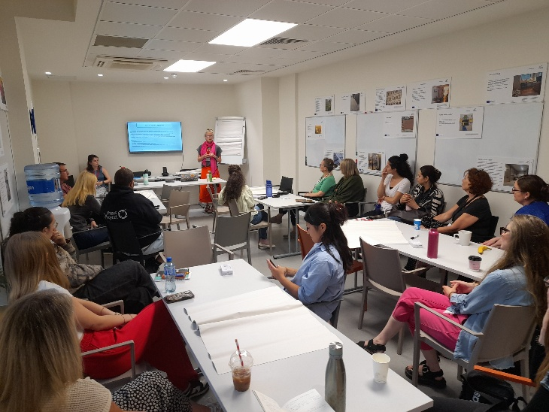
Small-group discussions based on learning from the Women’s Visual Voices, revealed that participants had a wealth of ideas for improving services and making them safer for women. While many recommendations related to policy change, participants also identified numerous practical improvements that require little or no additional funding and could be implemented within existing services. One of the strongest ideas emerging from the day was the value of meeting regularly to strengthen cooperation and improve information sharing between organisations. Several participants commented on the inherent value of co-designing responses with women using services, as well as appreciating the chance to step away from the demands of everyday practice, to use the learning from the women’s voices to reflect on their own services from a fresh perspective, and also learn from the perspectives of other participants before returning to their work with renewed motivation.
Supporting women experiencing homelessness requires broad collaboration across many sectors. Strengthening partnerships between organisations and creating regular opportunities to share knowledge and experience is an important step in this process and in the process of ending the injustices of homelessness. We are looking forward to continuing this work and bringing Women's Visual Voices to new allies, whether through training sessions or exhibitions, wherever organisations are interested in using the project.
